**THE KERAMA ISLANDS**

The **Kerama Islands** are a subtropical island group 32 kilometres (20 mi) southwest of [Okinawa Island](https://en.wikipedia.org/wiki/Okinawa_Island) in Japan.

Four islands are inhabited: [Tokashiki Island](https://en.wikipedia.org/wiki/Tokashiki_Island" \o "Tokashiki Island), [Zamami Island](https://en.wikipedia.org/wiki/Zamami_Island" \o "Zamami Island), [Aka Island](https://en.wikipedia.org/wiki/Aka_Island), and [Geruma Island](https://en.wikipedia.org/wiki/Geruma_Island" \o "Geruma Island).[[2]](https://en.wikipedia.org/wiki/Kerama_Islands#cite_note-2) The islands are administered as [Tokashiki Village](https://en.wikipedia.org/wiki/Tokashiki,_Okinawa" \o "Tokashiki, Okinawa) and [Zamami Village](https://en.wikipedia.org/wiki/Zamami,_Okinawa" \o "Zamami, Okinawa) within [Shimajiri District](https://en.wikipedia.org/wiki/Shimajiri_District,_Okinawa" \o "Shimajiri District, Okinawa), The Kerama-shotō coral reef is a [Ramsar Site](https://en.wikipedia.org/wiki/Ramsar_sites_in_Japan).

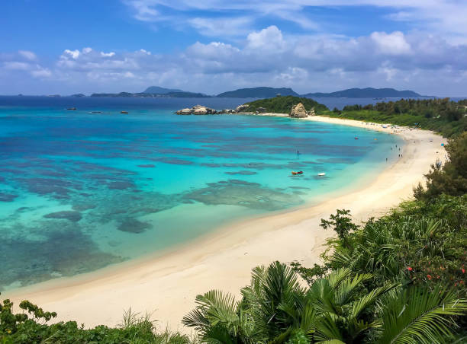

Kerama Shotō National Park is a national park in Okinawa Prefecture, Japan. Established in 2014, it is located in and around the **Kerama Islands**.